WEEK 2

- Use interactive Shell to print:
• User said "Great app!"
• C:\new_folder\test\
Example 1: (\n)
• Input: User said "Great app!"\nC:\new_folder\test\
• Output: User said "Great app!"
C:\new_folder\test\
Example 2: (\t) • Input: User said\t"Great app!"
• Output: User said "Great app!"
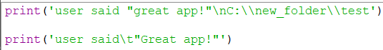
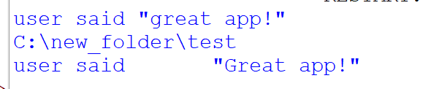

- A shopkeeper uses Python shell for quick billing calculations. Evaluate: 8+12, 94, 15-7, 18/3, 19/4, 19%4, 12%3, 37-5, 10-3*6-2
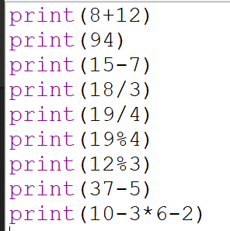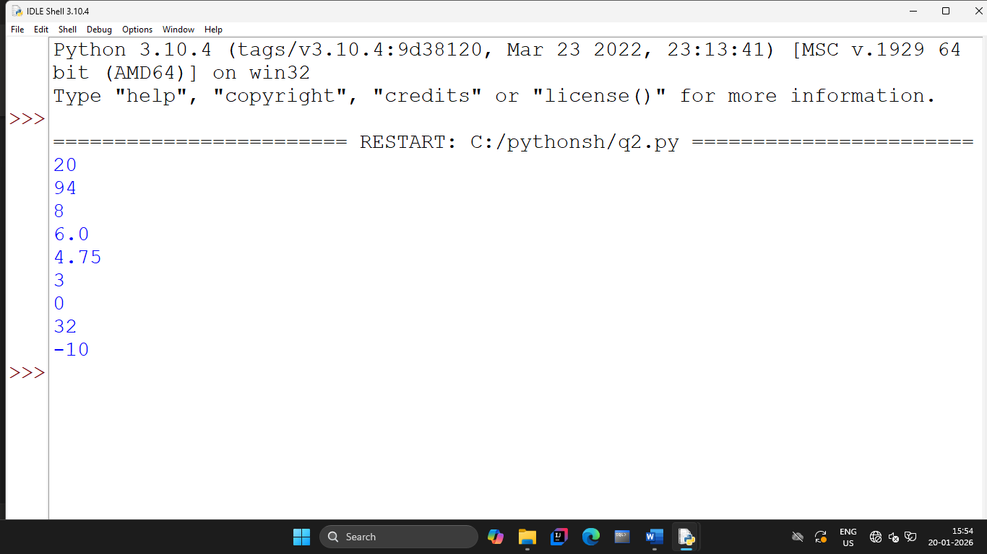

- A college form stores student names. Create variables firstName and lastName with your own names.
- Print firstName and lastName in single line. (use f"") (Try: print(firstName, lastName)
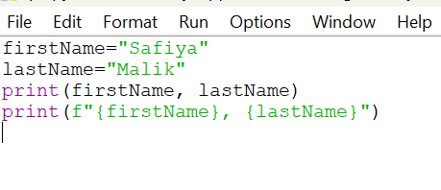
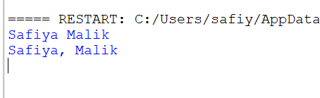

- A heritage museum kiosk needs an automated display-and-billing script. Create a single Python file kioskSystem.py that performs the following:
i) Billing Module:
The museum café calculates totals for simple arithmetic checks. Write code to compute and print results for:
• 10 + 5
• 12 * 4
• 25 - 8
• 30 / 7
• 30 % 3
ii) Information Display Module:
After billing output, print two separate informational messages for visitors:
• "Welcome to the National Art Museum"
• "Digital exhibits were introduced in 2015"
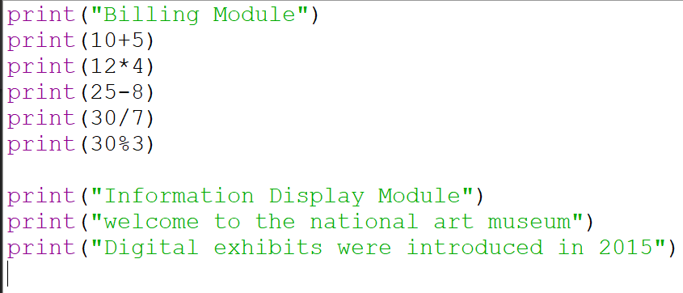
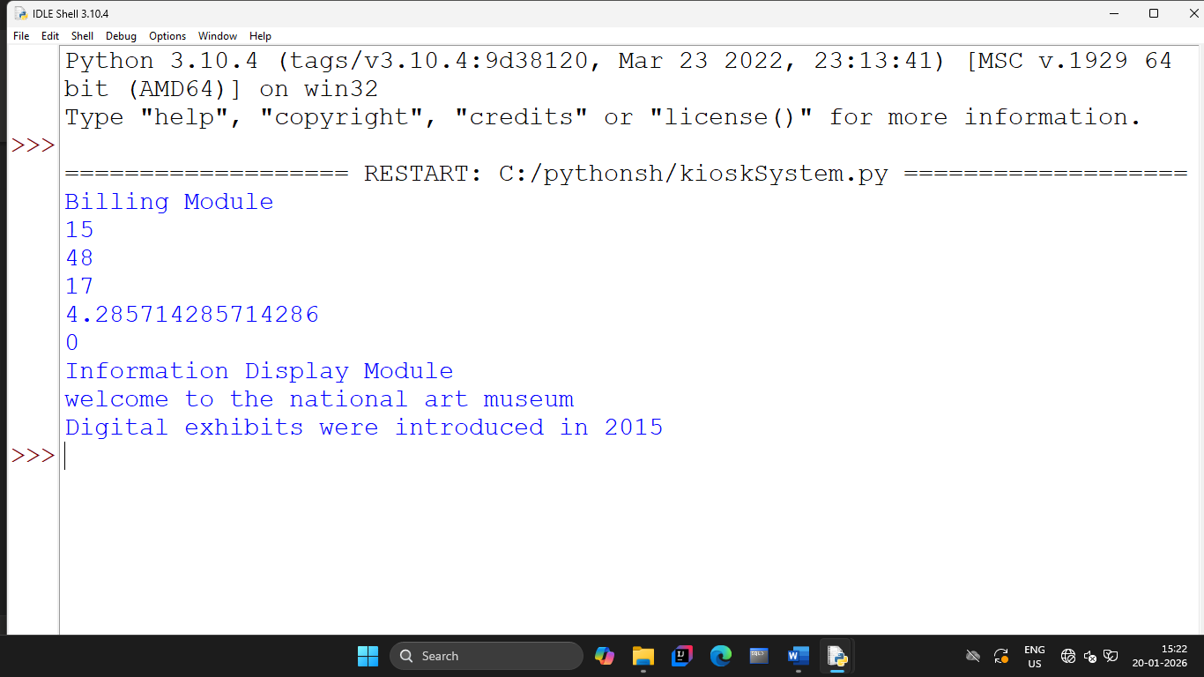

- An engineer calculates load using a polynomial. Given a=3, b=-2, c=6, d=1, e=4, f=7 and input x,
Compute: ax⁵ + bx⁴+ cx³ + dx² + ex + f^{1/2}
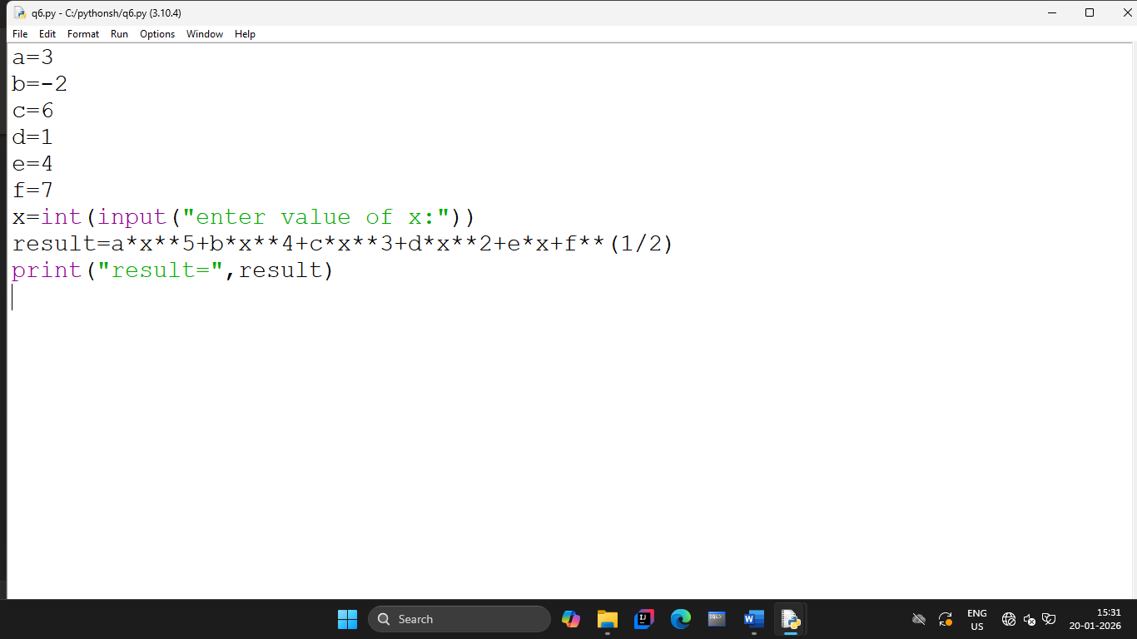
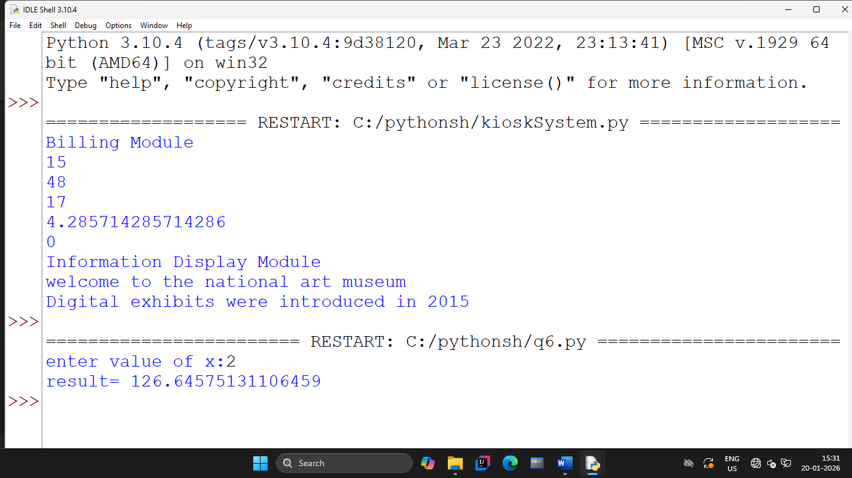

- Write a program to compute the value of following algebraic expression-
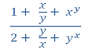
The value of x and y will be read using input () function.
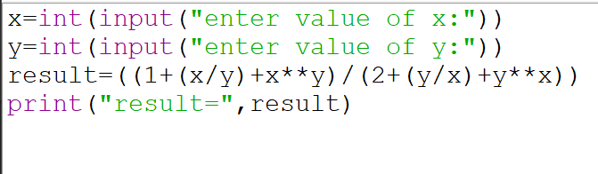
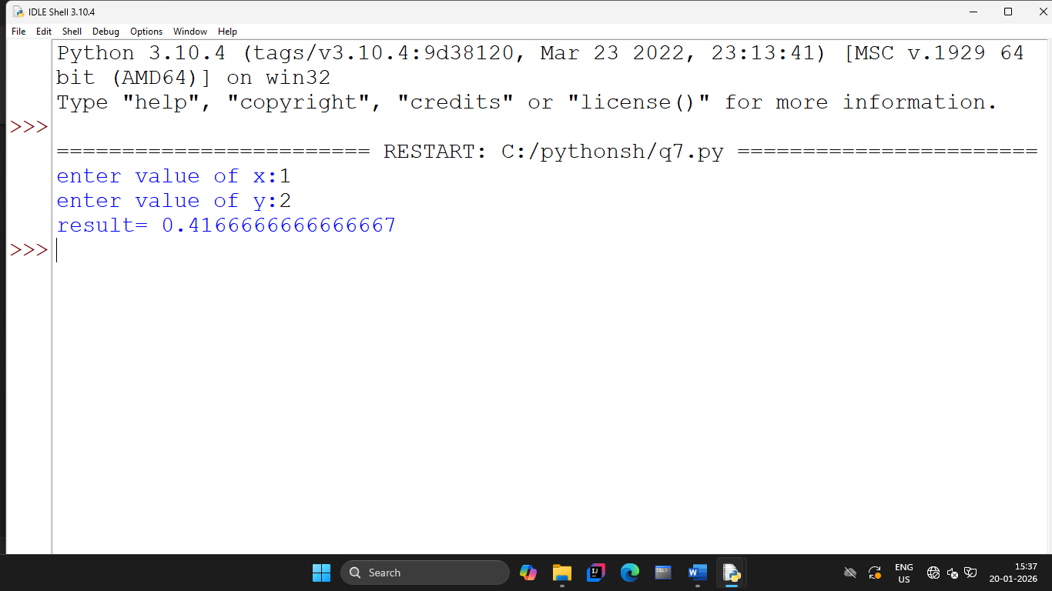

- A technician optimizes multiplication using bitwise operations. Read an integer and multiply it by 2 using <<
